**Manuscript Template**

John M. Author¹*, Jane D. Researcher², Samuel A. Writer³

¹Department of Civil Engineering, Bright State University, Nigeria  
²Department of Electrical Engineering, Federal University of Excellence, Nigeria  
³Department of Chemical Engineering, TechGlobal Institute, Ghana  
  
¹john.author@bsu.edu.ng, ²jane.researcher@fue.edu.ng, ³samuel.writer@tgi.edu.gh  
*Corresponding Author: john.author@bsu.edu.ng | +234-701-123-4567

**ABSTRACT**

This manuscript template is designed to guide prospective authors in preparing articles for submission to JERTI. The abstract must provide a concise summary of the research objectives, methods, key results, and conclusions. It should not exceed 250 words and must stand alone without citations or references.

**Keywords:** Engineering Innovation, Technology Advancement, Manuscript Guidelines, Peer Review, JERTI

1. **INTRODUCTION**

Provide background, research problems, and objectives.

1. **MATERIALS AND METHODS**

Detail methods used for the study.

* 1. **Sub sections:** Provide sub sections in the section

1. **RESULTS AND DISCUSSION**

Present and interpret results.

* 1. **Sub sections:** Provide sub sections in the section

Equations should be written using the MS Word Equation Editor, cited and numbered appropriately:

$\frac{x}{y}+ \frac{x}{z}=20$ (1)

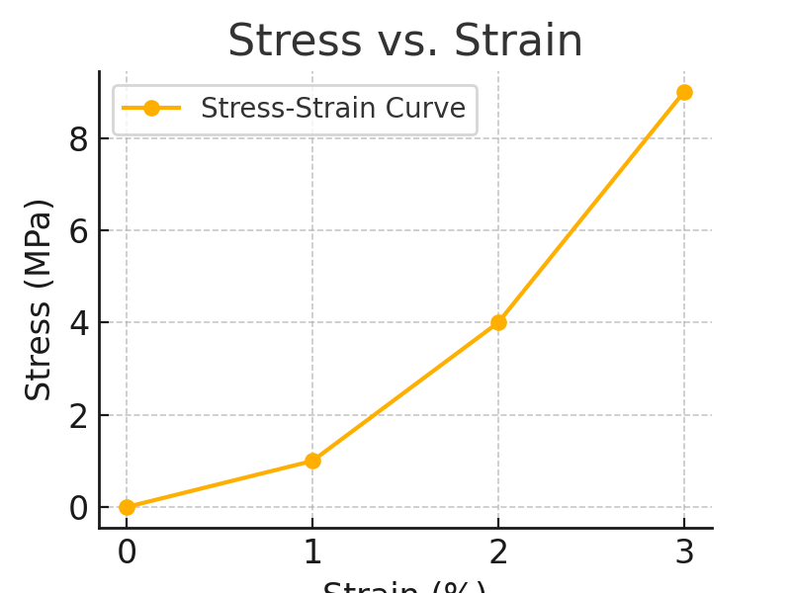

**Figure 1:** Sample graph showing relationship between stress and strain.

**Table 1:** Mechanical properties of selected materials.

|  |  |  |
| --- | --- | --- |
| **Material** | **Stress (MPa)** | **Strain (%)** |
| Steel | 250 | 0.2 |
| Aluminum | 150 | 0.3 |
| Concrete | 40 | 0.05 |

1. **CONCLUSION**

Summarize major findings and contributions.

**REFERENCES**

Adeleke, R. T., & Musa, A. W. (2022). Reinforcement methods in civil structures. Journal of Construction Engineering, 45(3), 233–248.

Nwosu, C. I. (2020). Advanced materials for sustainable engineering. Lagos: TechLine Publishers.

Agbo, F. K., & Ojo, B. S. (2021). Simulation of flow dynamics in reservoirs. In Proceedings of the Nigerian Engineering Conference (pp. 120–128). Abuja, Nigeria.