Title of Manuscript
John M. Author¹*, Jane D. Researcher², Samuel A. Writer³ (These should not be included in the main manuscript)
¹Department of Civil Engineering, Bright State University, Nigeria
²Department of Electrical Engineering, Federal University of Excellence, Nigeria
³Department of Chemical Engineering, TechGlobal Institute, Ghana
¹john.author@bsu.edu.ng, ²jane.researcher@fue.edu.ng, ³samuel.writer@tgi.edu.gh
*Corresponding Author: john.author@bsu.edu.ng | +234-701-123-4567
ABSTRACT
This paper presents a systematic investigation of an engineering problem using analytical, experimental, and computational approaches. The study aims to evaluate key performance parameters and identify factors influencing system efficiency and reliability. Relevant data were obtained through controlled experimentation and numerical analysis, and the results were validated against established theoretical models. Findings indicate improved performance under optimized conditions, demonstrating the practical relevance of the proposed approach. The outcomes of this research contribute to existing knowledge and provide useful insights for engineering practice and future studies in related fields.
Keywords: Engineering Innovation, Technology Advancement, Manuscript Guidelines, Peer Review, JERTI (Not more than five words)

- INTRODUCTION
Engineering research plays a critical role in addressing contemporary societal challenges such as infrastructure development, energy sustainability, environmental protection, and technological advancement. The rapid growth of population, urbanization, and industrial activities has increased the demand for innovative engineering solutions that are efficient, cost-effective, and environmentally responsible. Consequently, there is a growing need for research-driven approaches that integrate theory, experimentation, and practical application (Odeyemi et al., 2024).
Recent advancements across various engineering disciplines—including civil, mechanical, electrical, computer, agricultural, mining, and food engineering—have demonstrated the importance of interdisciplinary collaboration in solving complex real-world problems. Emerging technologies such as artificial intelligence, smart materials, renewable energy systems, and sustainable construction methods continue to reshape engineering practice and research priorities. These developments require continuous investigation, validation, and dissemination through credible scholarly platforms (Cervigni et al., 2013).
This study is motivated by the need to contribute to the existing body of knowledge by examining a specific engineering problem using established scientific methods. The research aims to present clear methodologies, reliable results, and meaningful discussions that can inform both academic research and professional practice. By doing so, the work aligns with the objectives of the Journal of Engineering Research and Technological Innovations (JERTI), which seeks to promote high-quality research, foster innovation, and support technological advancement across diverse fields of engineering (Sotannde et al., 2012).
- MATERIALS AND METHODS
Detail the methods used for the study.
  - Subsections: Provide subsections in the section
2.1.1 Sub Subsections

- RESULTS AND DISCUSSION
Present and interpret results.
  - Subsections: Provide subsections in the section
3.1.1 Sub Subsections
Equations should be written using the MS Word Equation Editor, cited and numbered appropriately:
$\frac{x}{y}+ \frac{x}{z}=20$ (1)
Figures should align with the Journal template as specified:
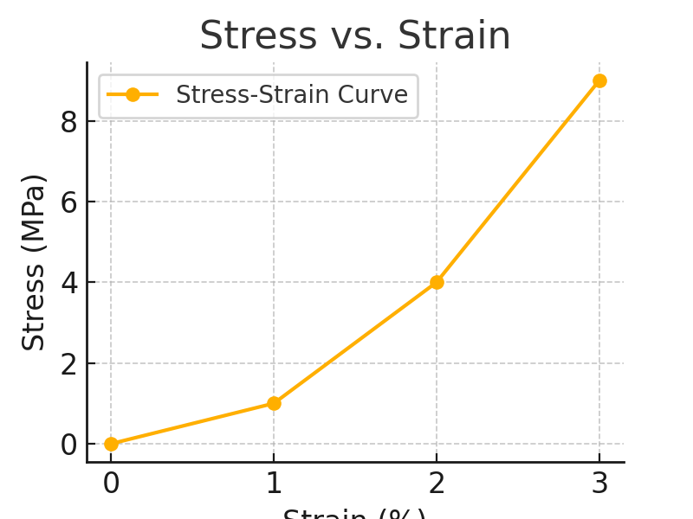
Figure 1: Sample graph showing the relationship between stress and strain. (Yusoff et al., 2015)

(a)

(b)
Figure 2: Stress date (a) Strain in the wire (b) Strain in the chord. (Sotannde et al., 2012)
Table 1: Mechanical properties of selected materials.
Material | Stress (MPa) | Strain (%)
Steel | 250 | 0.2
Aluminum | 150 | 0.3
Concrete | 40 | 0.05

- CONCLUSION
The following conclusions were drawn from the study:
- The adopted methodology proved effective in analysing the engineering problem and produced results that are consistent with established theoretical and empirical findings.
- The results obtained indicate that the proposed approach enhances system performance and reliability under the investigated conditions.
- The study provides practical insights that can support engineering decision-making and serves as a useful reference for future research in related areas.
REFERENCES
Cervigni, R., Rogers, J. A., & Henrion, M. (2013). Low-Carbon Development. In Low-Carbon Development. https://doi.org/10.1596/978-0-8213-9925-5
Odeyemi, S. O., Durosinlorun, A. O., & Wilson, U. N. (2024). Determination of Physical and Mechanical Properties of Fibre-Reinforced Coconut Shell Concrete. Civil Engineering Infrastructures Journal, 57(2), 423–430. https://doi.org/10.22059/CEIJ.2023.358739.1919
Sotannde, O. A., Oluwadare, A. O., Ogedoh, O., & Adeogun, P. F. (2012). Evaluation of cement-bonded particle board produced from Afzelia africana wood residues. Journal of Engineering Science and Technology, 7(6), 732–743.
Yusoff, M., Abdul Hamid, N. H., Arshad, A. K., Mohd Ridzuan, A. R., & Awang, H. (2015). InCIEC 2015 Proceedings of the International Civil and Infrastructure Engineering Conference. Springer, Singapore. https://doi.org/https://doi.org/10.1007/978-981-10-0155-0

